**AIM**:- Case study on Service oriented architecture.

**DEFINATION**:-

-A **service**-**oriented architecture** (**SOA**) is an architectural pattern in computer software design in which application components provide services to other components via a communications protocol, typically over a network. The principles of **service**-**orientation** are independent of any vendor, product or technology.

**ARCHITECTURE**:-

-A reference architecture is a more concrete artifact used by architects. Unlike the reference model, it can introduce additional details and concepts to provide a more complete picture for those who may implement a particular class. Reference architectures declare details that would be in all instances of a certain class, much like an abstract constructor class in programming. Each subsequent architecture designed from the reference architecture would be specialized for a specific set of requirements. Reference architectures often introduce concepts such as cardinal

-ity, structure, infrastructure, and other types of binary relationship details. Accordingly, reference models do not have service providers and consumers. If they did, then a reference model would have infrastructure (between the two concrete entities) and it would not longer be a model.

-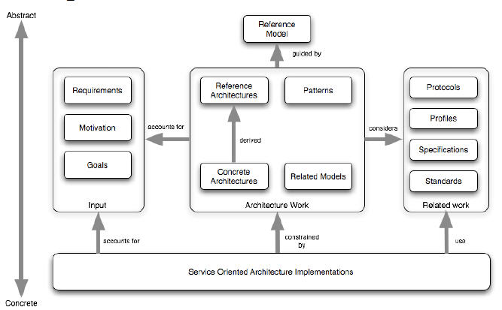The reference model and the reference architecture are intended to be part of a set of guiding artifacts that are used with patterns. Architects can use these artifacts in conjunction with others to compose their own SOA. The relationships are depicted in Figure

-The concepts and relationships defined by the reference model are intended to be the basis for describing reference architectures that will define more specific categories of SOA designs. Specifically, these specialized architectures will enable solution patterns to solve particular problems. Concrete architectures may be developed based upon a combination of reference architectures, architectural patterns, and additional requirements, including those imposed by technology **Example**:- Enterprise Service-Oriented Architecture with Cloud Computing

The following diagram is an example of a service-oriented architecture using Web Services. Click on the yellow boxes below to obtain more information on a subject. **Example**

environments. Architecture is not done in isolation; it must account for the goals,

motivation, and requirements that define the actual problems being addressed. While reference architectures can form the basis of classes of solutions, concrete architectures will define specific solution approaches.Architects and developers also need to bind their own SOA to concrete standards technologies and protocols at some point. These are typically part of the requirements process. For example,

when building a highly efficient client side Mashup application, a developer might opt for the

**CONCLUSION**:-